

Probhonjan Barua

Class of 2017

8011606045

Research officer at Genome institute, Singapore

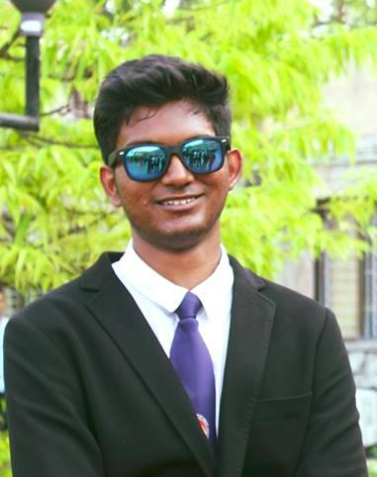

Manu Tej Sharma

Class of 2018

8639959310

Student at Georgia Tech



Ravinder Kumar

Class of 2018

7896375074

Executive Engineer at ONGC, Hazira

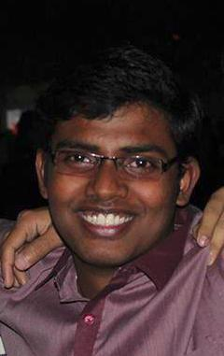

Abhra Gosh

Class of 2016

8884614495

Specialist Programmer at Infosys Limited